Circle Language Spec

Object Reference
An object can contain sub-objects, as explained in the article Sub-Objects. A sub-object can also point to another object, that actually resides elsewhere in the system, so that an existing object can function as another object’s sub-object. In that case the sub-object is an object reference, that redirects to another object.

An object reference is also called a pointer.

When a sub-object is actually an object reference, pointing to an object elsewhere in the system, then the symbol representing the sub-object will get a line, that is connected to the symbol representing the actual object, which usually resides outside the parent object.

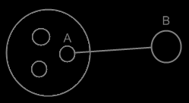

The sub-object A is an object reference to object B. Object references usually point outwards, out of an object.

